*OPPO mobile*

OPPO A96

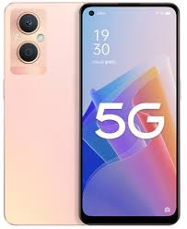

**Oppo A96** ; OS, Android 11, ColorOS 11.1 ; Chipset, Qualcomm SM6225 Snapdragon 680 4G (6 nm) ; CPU, Octa-core (4x2.4 GHz Kryo 265 Gold & 4x1.9 GHz Kryo 265 Silver).

**PRICE /** 77,999 **PRK**